## USABILITY TESTING

Testing the user friendliness of an application is called as Usability Testing

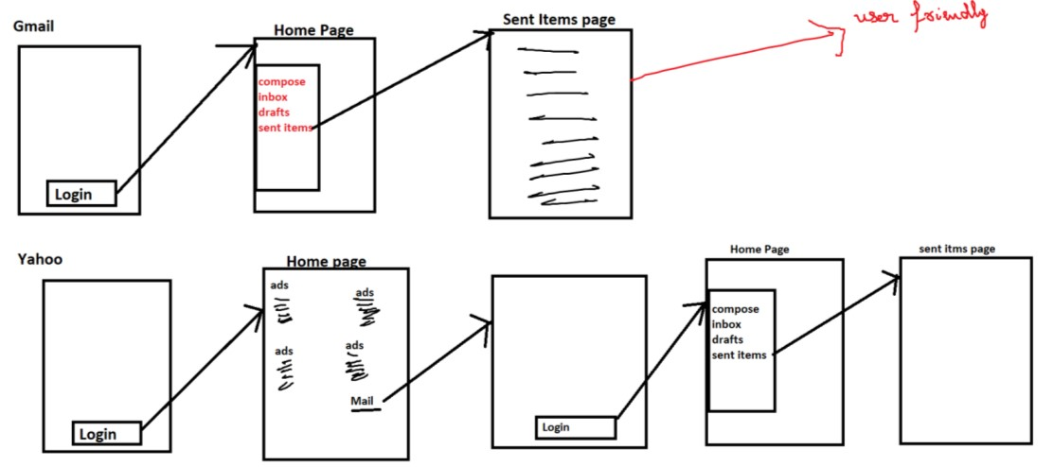

**How to do Usability Testing?**

1. Here we will check whether look and feel of the application is good or not.
2. Here we will check whether it is easy to understand or not (or) I will check whether I’m able to understand within less time.
3. Frequently used features/important features must be given to users within 3 clicks
4. Frequently used features/important features must be easily accessible.

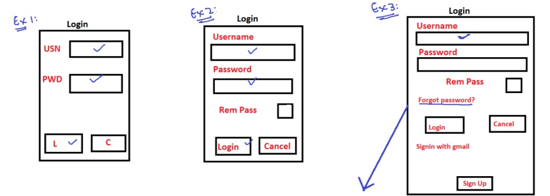

**For what kind of applications, we should do usability testing?**

1. Any application which is used by variety of users
2. Any application which generates lot of revenue
3. Any application wherein we don’t provide training to user about how to use the application, we are expecting the end users himself to understand the application and use.

**When we should do usability testing?**

In different projects they start usability testing in different stages:

1. In certain projects they do UT when the product becomes functionally stable